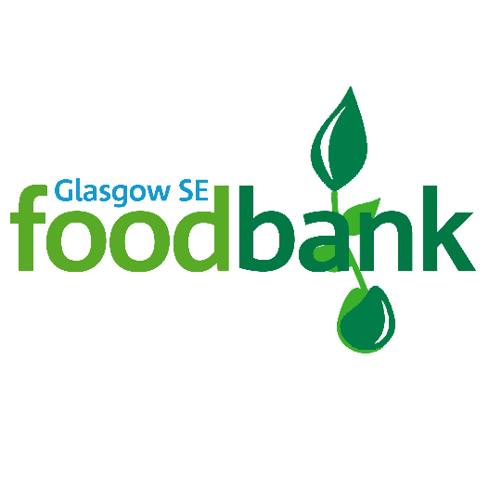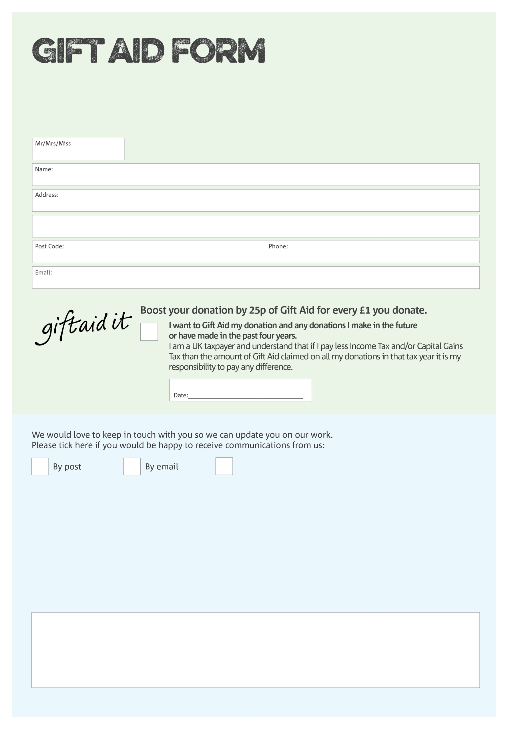

By filling in this form Glasgow SE Foodbank will receive an extra 25p for every £1 you give at no extra cost to you. Thank you!

You can change your preferences any time by contacting us on 0745 6868 628 or emailing us at admin@glasgowse.foodbank.org.uk

We would love to know why you have chosen to donate to Glasgow SE Foodbank. If you would like to share your motivation let us know below:

**Data protection**

*Glasgow SE Foodbank is committed to protecting your privacy and will process your personal data in accordance with current Data Protection legislation. Glasgow SE Foodbank collects information to keep in touch with you and supply you with information relating to our work. To unsubscribe from our newsletter, send a message to the email address above with the word unsubscribe in the subject line. A full data privacy statement for financial donors is available from the foodbank on request.’*

I do not wish to receive future communications from Glasgow SE Foodbank

Charity Number SCO43981. Registered in Scotland