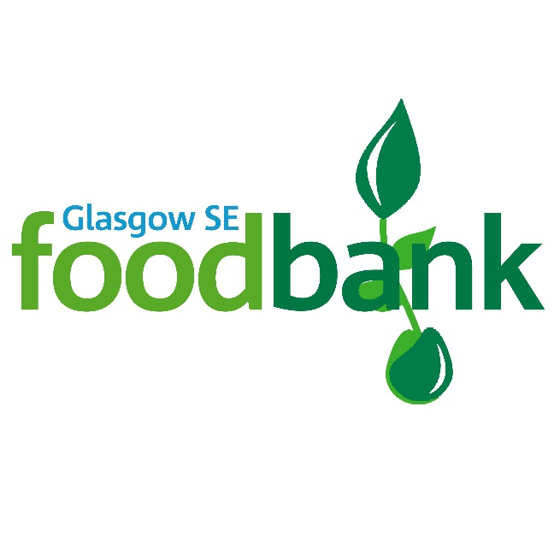

P4: Volunteer Application Form

Glasgow SE Foodbank
Unit 1, Govanhill Workspace
69 Dixon Road
Govanhill
Glasgow
G42 8AT
Tel No: 0745 6868 628
Email:
admin@glasgowse.foodbank.org.uk
Registered charity number SC043981
Thank you for your offer to help with Glasgow SE Foodbank.
In order for your application to be processed, please
answer the following questions:

(If you have any questions about your application or would like help
completing it please contact Audrey Flannagan at the address opposite)

Your Name:
Address:
Postcode:
References (please note that neither referee should be a close family relation or a Trussell Trust Employee)
Referee 1

Referee 2

Email:
Tel No:
Date of Birth:

Next of Kin:
Name:
Tel No:
Relationship:

Contact in case of emergency (if different from above)
Name:
Tel No:
Relationship:

At present our only vacancies are in the Foodbank Centre & ad hoc events

Please tick which you would be interested in:

Ad hoc events

Foodbank Centre

Our opening hours, for volunteers are between 10am and 2pm Mon, Wed & Fri. You can work part or all of a session. This will be further discussed at the information meeting.
Do you have any health problems that we should be aware of? Yes No
details:

Please tell us your previous work experience or qualifications:

Are you willing to complete a form for us to submit for a Criminal Records Bureau check?
Yes No

If you have any criminal convictions (except those ‘spent’ under the Rehabilitation of
Offenders Act) please give details:

Please State your reasons for volunteering:

Please give us any information you think may be useful to us:

Data protection:
I confirm that the above information is complete and correct. I consent to the processing of this data in the consideration of my application and during the course of my volunteering, where applicable.

Signature: Date:

Please return this form to Audrey Flannagan, Glasgow SE Foodbank, 42 Inglefield Street, Glasgow G42 7AT

