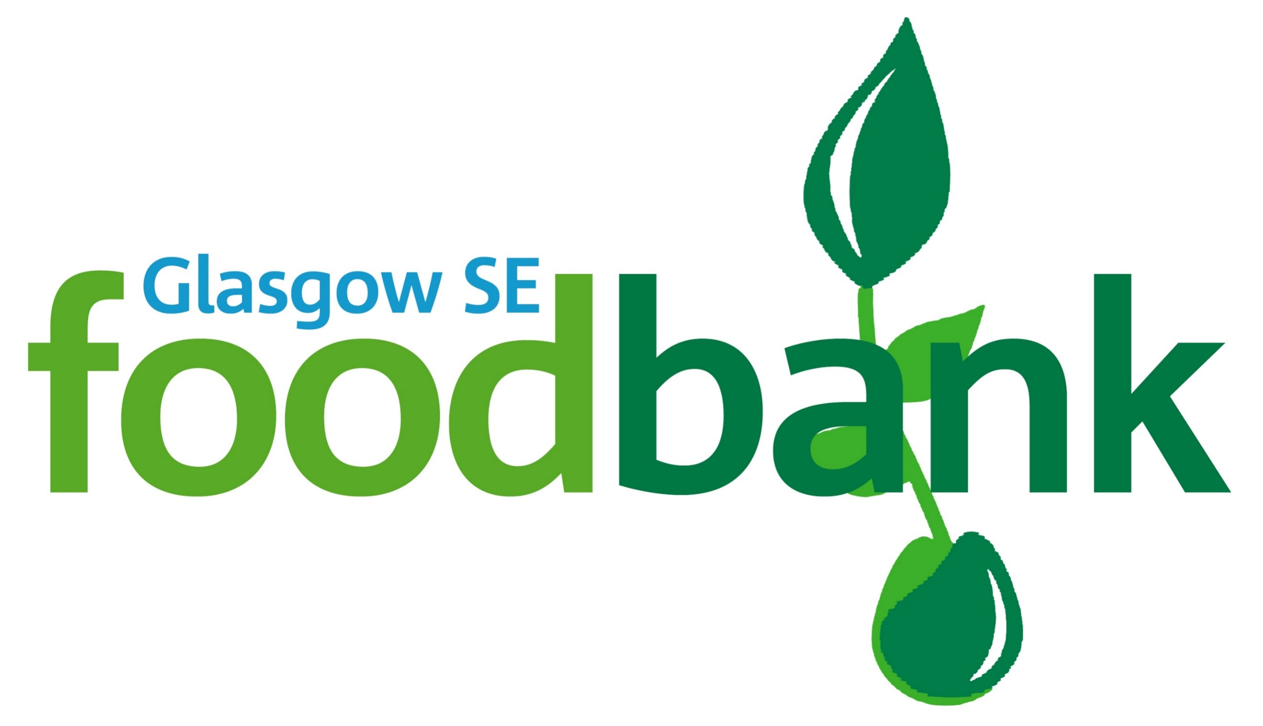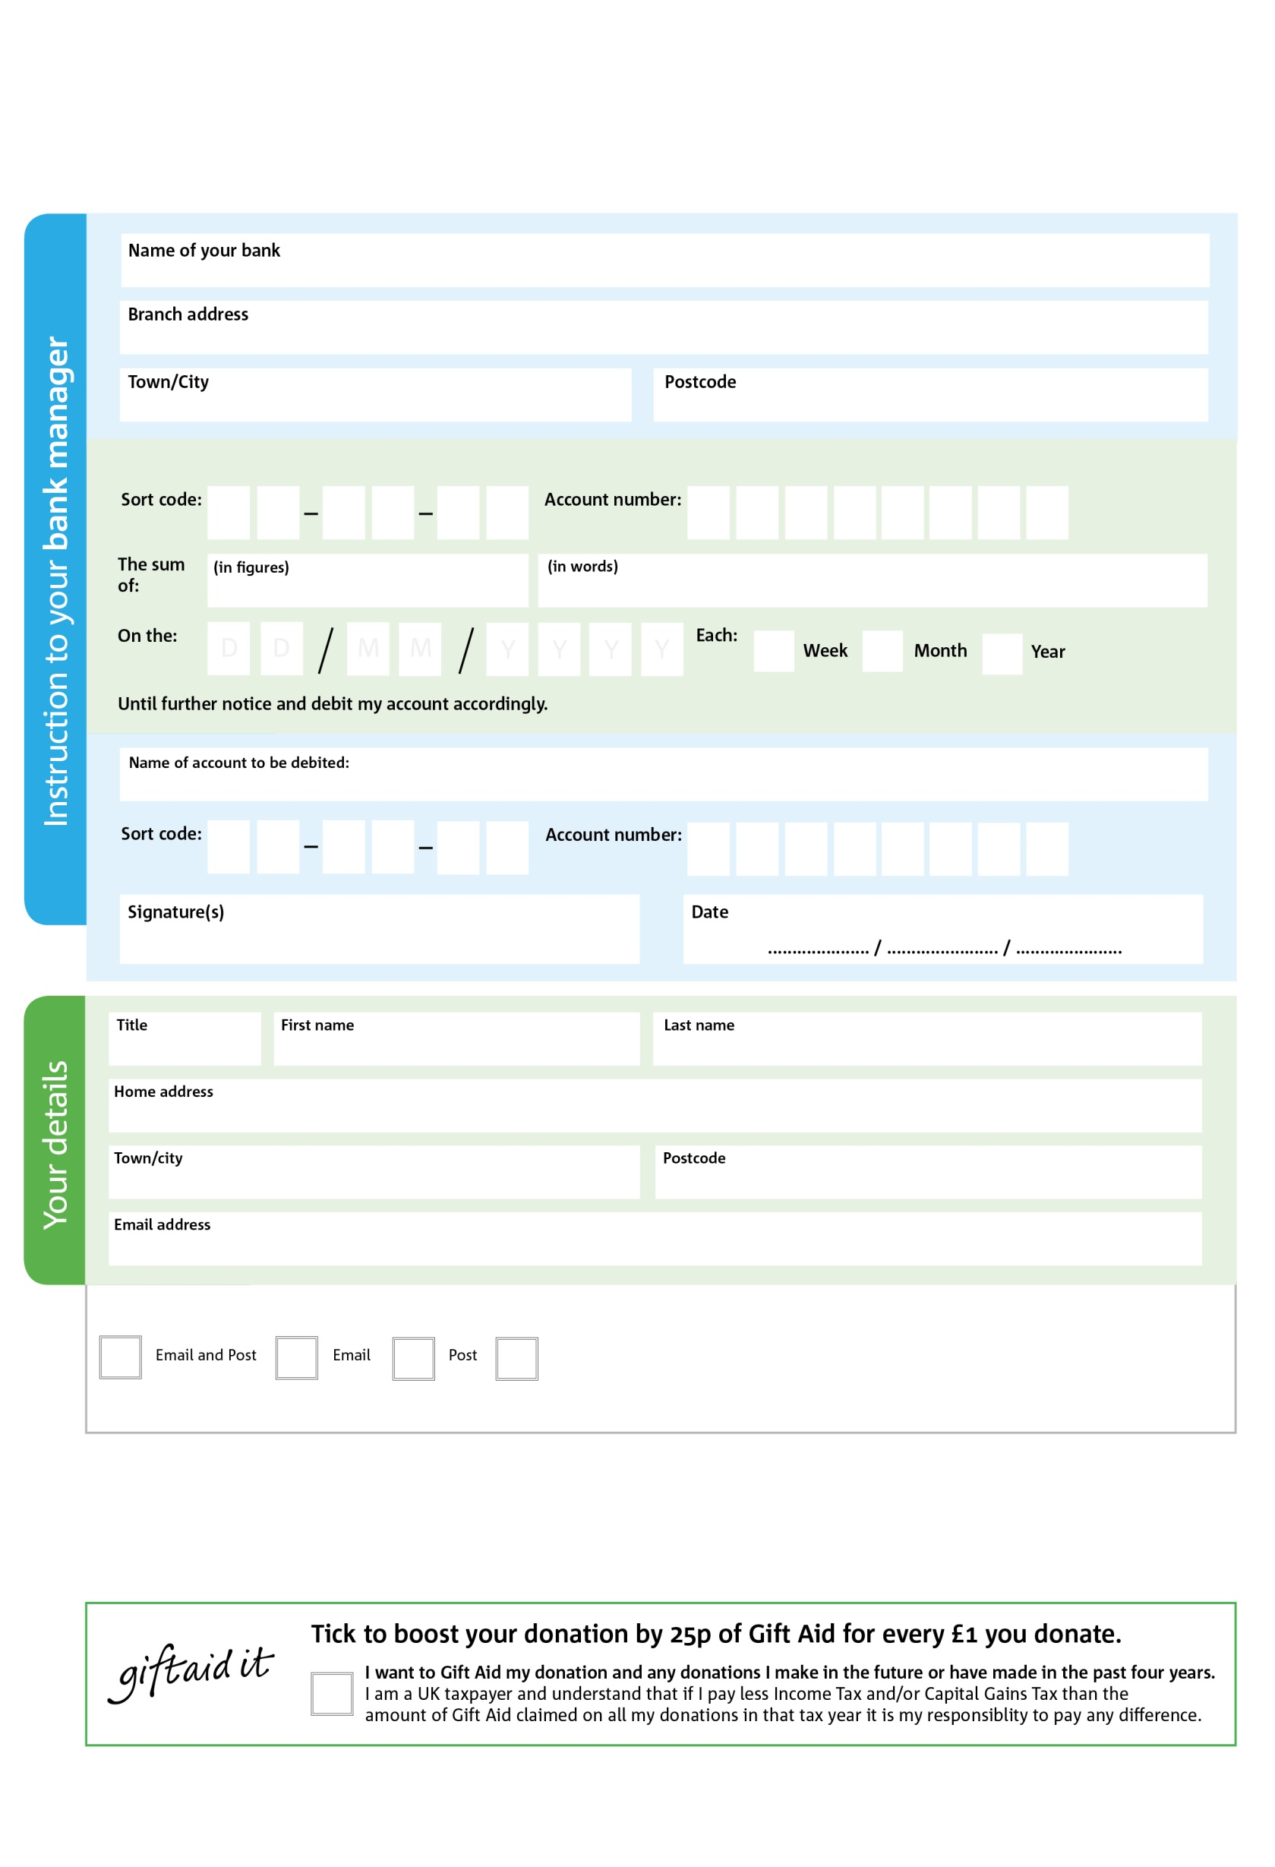

**Standing Order Mandate**

**admin@glasgowse.foodbank.org.uk**

POSTAL ADDRESS: Glasgow SE Foodbank, Unit 1, Govanhill Workspace, 69 Dixon Road, Govanhill , Glasgow, G42 8AT

Registered In Scotland SCO43981

7

V

9

V

1

V

1

V

2

V

0

V

0

V

1

V

**Please pass this form onto the foodbank, using the foodbank’s address at the bottom, who will save a copy for their records.   
They will then send it onto your named bank or building society.**

7

2

4

6

2

8

We would love to keep you up to date with information about Glasgow SE Foodbank. Please tick your preference:

You can change your preferences any time by contacting us on 0745 6868 628 or emailing us at admin@glasgowse.foodbank.org.uk

I do not wish to receive future communications from Glasgow SE Foodbank

Please pay Glasgow SE Foodbank,

**Data protection**

*'Glasgow SE Foodbank is committed to protecting your privacy and will process your personal data in accordance with current Data Protection legislation. Glasgow SE Foodbank collects information to keep in touch with you and supply you with information relating to our work. To unsubscribe from our newsletter, send a message to the email address above with the word unsubscribe in the subject line. A full data privacy statement for financial donors is available from the foodbank on request.’*